**LAB NO 09**



**Fall 2024**

**CSE-304L Computer Organization and Architecture Lab**

Submitted by:

Name : **Hassan Zaib Jadoon**

Reg no**. : 22PWCSE2144**

ClassSection **: A**

Signature: ____________

Submitted to:

**Dr. Amaad Khalil**

**Department of Computer Systems Engineering**

**University of Engineering and Technology, Peshawar**

**Introduction to MODELSIM and Gate-Level Modeling**

**Objectives:**

* Introduction to MODELSIM software.
* Understanding the usage of MODELSIM for gate-level modeling and simulations.

**MODELSIM:**

MODELSIM is a powerful simulation tool used for simulating designs written in VHDL or Verilog HDL. It allows users to visualize, debug, and test designs efficiently. The interface is user-friendly, providing an environment for both beginners and advanced users in hardware description language simulation.

**How to Use MODELSIM:  
  
Step 1: Creating a New Project**

1. **Select** File > New > Project from the main window to create a new project. The **Create Project** dialog will appear, which includes the following options:
   * **Project Name**: Specify the name of your new project.
   * **Project Location**: Choose the directory where the .mpf file will be stored.
   * **Default Library Name**: Assign a working library name, typically left as "work."
2. Click **OK** to finalize the project creation. A blank **Project** tab will appear in the workspace, along with the **Add Items to the Project** dialog.

The name of your current project will be displayed at the bottom left corner of the **Main window**.

|  |  |
| --- | --- |
|  |  |

**Step 2: Adding Items to the Project**

In the **Add Items to the Project** dialog, there are several options:

* **Create New File**: Create new VHDL, Verilog, Tcl, or text files for your design.
* **Add Existing File**: Add an existing file to the project.
* **Create Simulation**: Define the source files and simulation configurations.
* **Create New Folder**: Organize your project files by creating folders.

To create a new file:

1. **File Name**: Enter the name for your new file.
2. **Add File as Type**: Choose the type of file (VHDL, Verilog, TCL, or text).
3. **Folder**: Choose the folder within the project where the file should be placed.

Click **OK**, and the Source window will open with an empty file, listed in the **Project** tab.

To add an existing file:

1. **File Name**: Browse and select the file you want to add.
2. **Add File as Type**: Select the file type (the default type is based on the file extension).
3. **Folder**: Specify the folder for the file.

You can choose whether to reference the file from its current location or copy it into the project directory.

|  |  |
| --- | --- |
|  |  |

**Step 3: Compiling the Files**

In the **Project** tab, files that have not been compiled are marked with a question mark. To compile the files:

1. Select **Compile > Compile All** or right-click the file in the **Project** tab and choose **Compile > Compile All**.

Once compiled, you can expand the **work** library in the **Library** tab to view the compiled design units.

**Step 4: Simulating the Design**

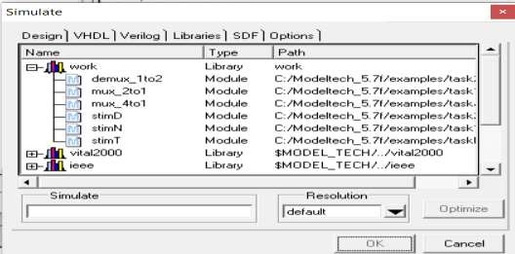To simulate a design:

1. Double-click or right-click the design unit and select **Simulate**.
2. A new tab will appear showing the structure of the active simulation.

You can then add signals to the **Wave** window and run the simulation for a specified time. This allows you to analyze the results and verify the behavior of your design.

**Program:** Example for the module instantiation

|  |  |  |
| --- | --- | --- |
|  |  |  |